Séminaire
Nordic Blue Humanities

Sorbonne Université/EPHE
2025-2026



Lieu : EPHE, Maison des Sciences de L'Homme (FMSH)
54 Boulevard Raspail, 75006 Paris

Organisateurs
Sylvain Briens, Sorbonne, sylvain.briens@sorbonne-universite.fr
Alessia Bauer, EPHE, alessia.bauer@ephe.psl.eu

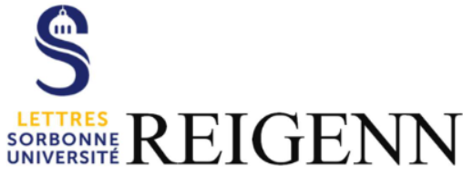

This project wishes to investigate the frameworks that can be applied to studying the current issue of climatic change from the perspective of a specifically Nordic environment. This project wishes to gather a panel of scholars across disciplines, bringing the School of Humanities and the School of Sciences of the Sorbonne into conversation on the hybrid topic of aesthetic and scientific innovation in environments such as the sea coast, the ocean or atmosphere. It will be placed under the sign of plurality and criss-crossing, including that between science and literature, by launching a think-tank whose ultimate aim will be to unite their forces to address the political decision-makers on the burning issue of ecology. The project wishes to provide a new hybrid approach to the contemporary emergence of critical currents such as ‘Blue Humanities,’ and argues towards a specifically Nordic version that will include a more global take on the Arctic and Baltic fluid environments and movements: ice, foam, atmosphere, drifting, and such. The project invites literature to reconnect with our contemporary society by contributing to a debate that has been a traditional field of scientific research. The perspective of Nordic literature will bring to the fore the ecological approach of a range of native writers and poets of the Nordic and circumpolar regions, most of them overlooked, among which features a number of women. This in turn will provide the groundwork for a reflection on ecocriticism and ecofeminism that will be part of the critical process towards a Nordic theory of ‘Light Blue Humanities.’

Les séminaires pourront être suivis en ligne en appuyant ici

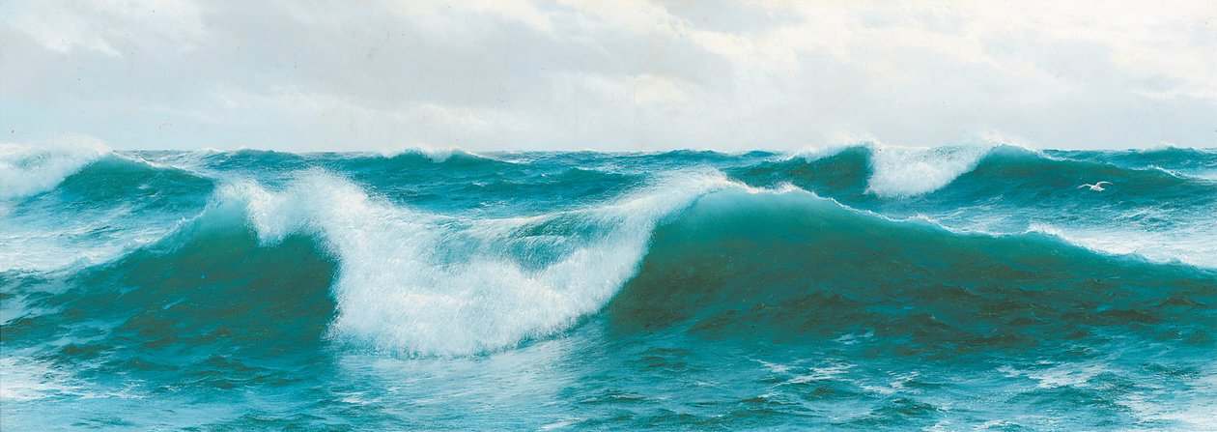

Vendredi 10 octobre 2025
14h00-17h00
Salle D052 Histoire
Sorbonne (1, rue Victor Cousin 75005 Paris)

Workshop on Ice Humanities
Ice age theories in Skandinavia and Russia
≈
Erki Tammiksaar (Université de Tartu)

Between the sky and the shining ice’: the first European expedition to the Greenland ice sheet 1729
≈
Emil Andersen (Musée National duDanemark)
Staging Ice
≈
Anna Street (Université du Mans)
Cryopoetics and Transoceanic Resistance in the Anthropocene
≈
Sylvain Briens (Sorbonne Université)

Vendredi 14 novembre 2025
14h00-16h00
Salle 1 (sous-sol) - FMSH
54 Boulevard Raspail, 75006 Paris

Archipelagic Obstructions: Archipelagic Thinking and Planetary Reach in Tomas Tranströmer’s Baltics
≈
Dan Ringgaard (Université d’Aarhus)

Vendredi 5 décembre 2025
14h00-16h00
Salle 1 (sous-sol) - FMSH
54 Boulevard Raspail, 75006 Paris

Open Waters – Art History seen from the Sea
≈
Ceciliae Weissert & Johannes von Müller (Université de Kiel)

Vendredi 30 janvier 2026
14h00-16h00
Salle 1 (sous-sol) - FMSH
54 Boulevard Raspail, 75006 Paris

Situated Waters – Mapping Nordic Literature through Bodies of Water
≈
Katie Ritson (Université de Munich) & Frederike Felcht (Université de Francfort/Université de Berkley)

Vendredi 13 février 2026
14h00-16h00
Salle 1 (sous-sol) - FMSH
54 Boulevard Raspail, 75006 Paris

Sea Foam – H.C. Andersen and the ever-changing Sea
≈
Klaus Müller-Wille (Université de Zurich)

